# GENERAL DEPLOYMENT GUIDELINES:

1. Download and install the Azure PowerShell commands:

You can download and install the Azure PowerShell module by running the [Microsoft Web Platform Installer.](https://www.microsoft.com/web/handlers/webpi.ashx/getinstaller/WindowsAzurePowerShell.3f.3f.3fnew.appids)



When prompted, click Run. The Microsoft Web Platform Installer loads, with the Azure PowerShell module available for installation.

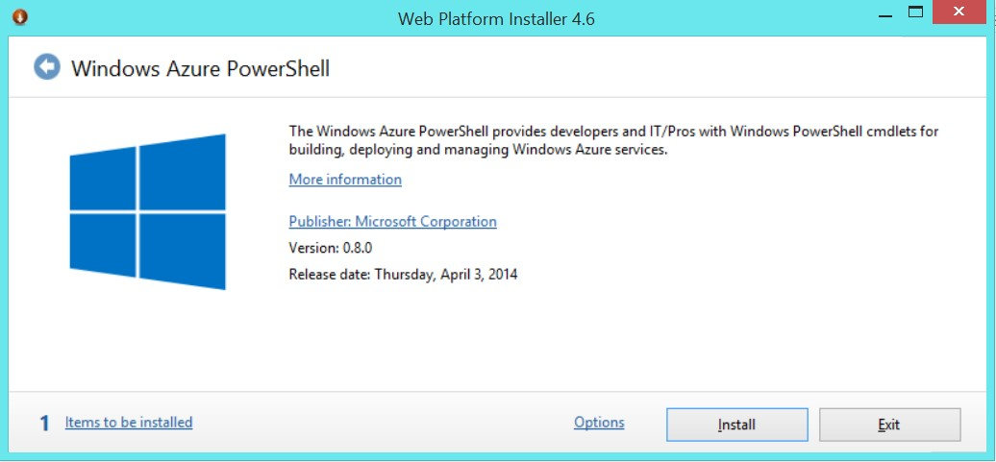

The Web Platform Installer installs all dependencies for the Azure PowerShell cmdlets.

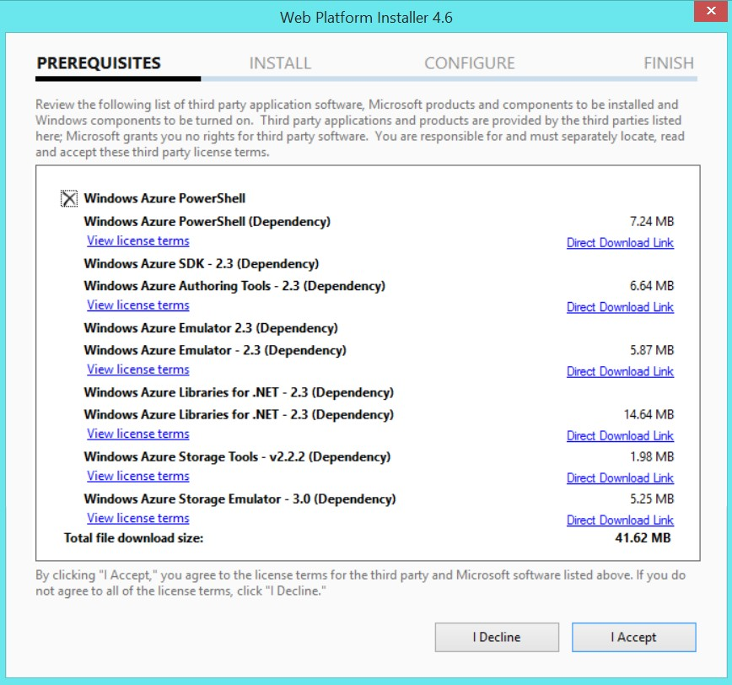

Follow the prompts to complete the installation.

1. Ensure that your subscription is correctly set, by running the following azure PowerShell command:

Get-AzureSubscription –Current

1. If your subscription is not set (as the below snapshot), follow the following steps:

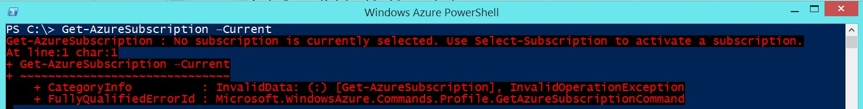

* + With your subscription open in IE run the command

Get-AzurePublishSettingsFile

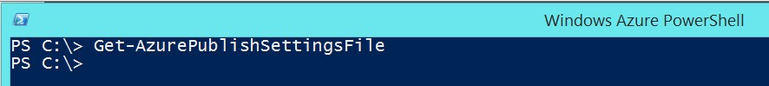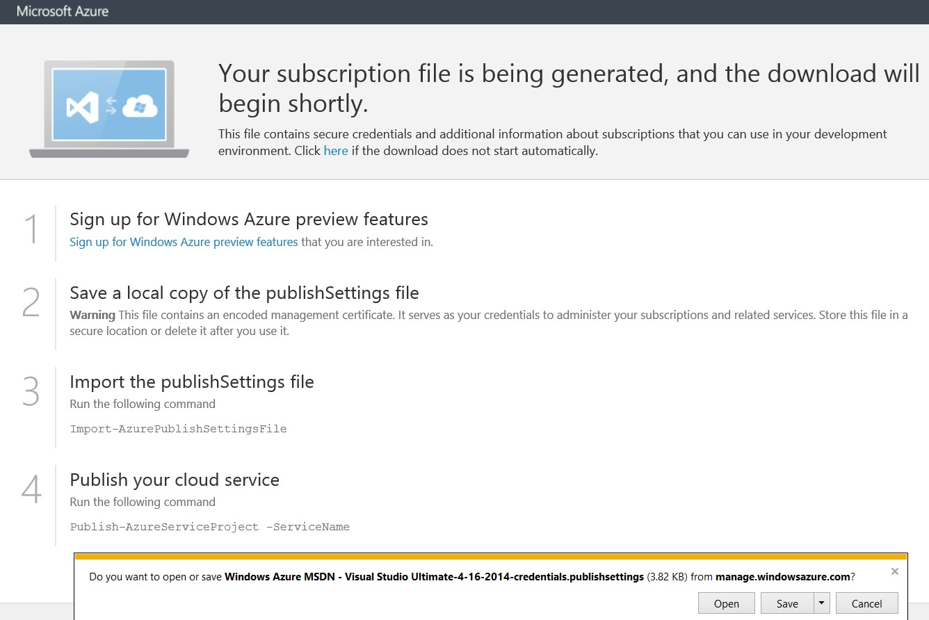

* + IE will automatically run and generate Subscription configuration file for you, you can save the XML file locally on machine HD, You can name it

“mysubscriptions.publishsettings”

* + Run the following command referring to the XML file that you just saved it locally

Import-AzurePublishSettingsFile

"C:\MyPublishSettings\mysubscriptions.publishsettings”



1. Now you can check with running the same previous command:

Get-AzureSubscription –Current

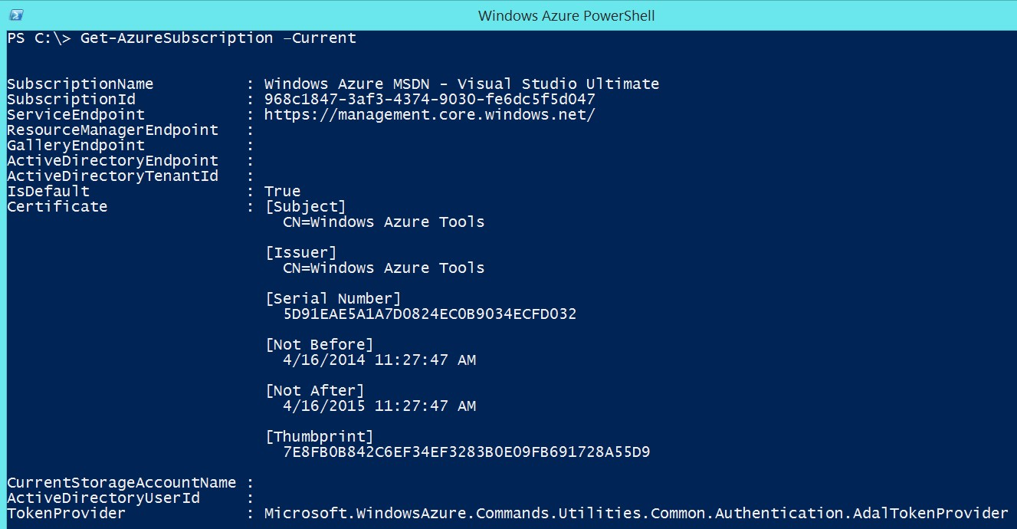

1. Open the master-deployment-script.ps1 in PowerShell_ISE (Run PowerShell as Administrator) or your favorite editor.

It is recommended to use PS Execution environment with a large console history as the scripts can output a lot of information and unless the console buffer is made much bigger output useful for troubleshooting could be list

1. Select the task no. 2.

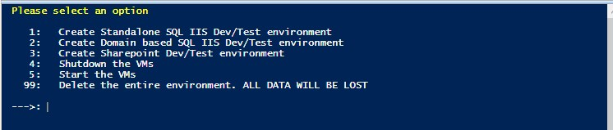

1. In location choice select 1.

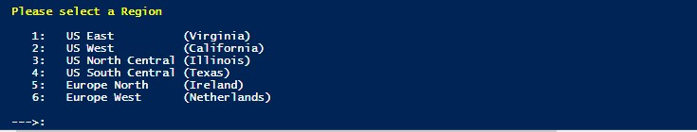

1. Ensure that your machine will not power off during the deployment. The deployment can take 2 or more hours.